Chapter 8: Quadratic expressions and algebraic fractions

Test A (40 marks)

Name: ___________________________________

Part A – Multiple-choice (10 marks)

1 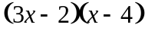 in expanded and simplified form is:

A 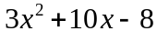 B 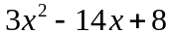 C 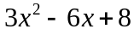

D 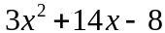 E 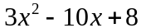

2 Which of the following mathematical statements is true?

A 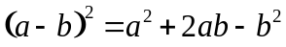 B 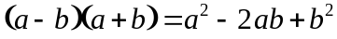

C 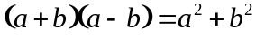 D 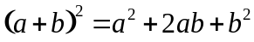

E 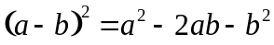

3 The highest common factor of 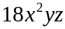 and 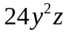 is:

A 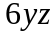 B 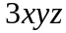 C 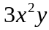

D 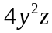 E 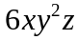

4 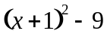 in factorised form is:

A 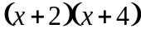 B 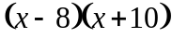 C 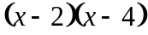

D 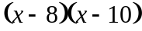 E 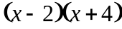

5 When factorising a quadratic trinomial of the form 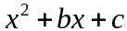, we need to find two numbers which:

A multiply to give b and add to give a

B multiply to give b and add to give c

C multiply to give c and add to give b

D multiply to give c and add to give a

E multiply to give a and add to give c

6 The first step of factorising 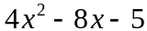 using the method of grouping is to write:

A 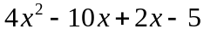 B 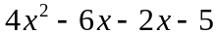 C 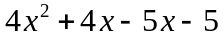

D 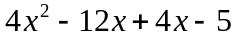 E 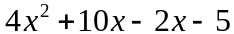

7 The simplified form of 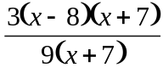 is:

A 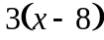 B 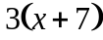 C 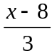

D 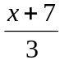 E

8 The simplified form of 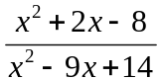 is:

A 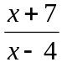 B 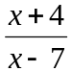 C 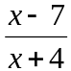

D 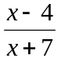 E This expression cannot be simplified any further

9 The lowest common denominator of 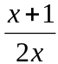 and 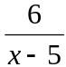 is:

A B 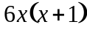 C 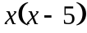

D 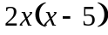 E 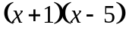

10 The solution to 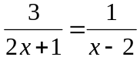 is:

A B C

D E

Part B – Short-answer (26 marks)

1 Expand and simplify each of the following.

a 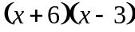 b 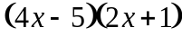

_________________________________ _________________________________

_________________________________ _________________________________

c 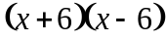 d 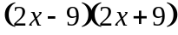

_________________________________ _________________________________

_________________________________ _________________________________

e 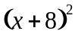 f 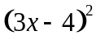

_________________________________ _________________________________

_________________________________ _________________________________

(6 × 1 = 6 marks)

2 Factorise the following.

a 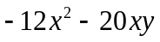 b 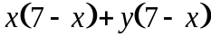

_________________________________ _________________________________

_________________________________ _________________________________

c 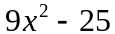 d 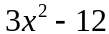

_________________________________ _________________________________

_________________________________ _________________________________

(4 × 1 = 4 marks)

3 Use the method of grouping to factorise these expressions.

a b 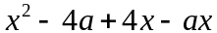

_________________________________ _________________________________

_________________________________ _________________________________

_________________________________ _________________________________

(2 × 1 = 2 marks)

4 Factorise each of the following quadratic trinomials.

a 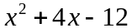 b 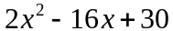

_________________________________ _________________________________

_________________________________ _________________________________

c 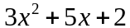 d 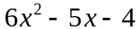

_________________________________ _________________________________

_________________________________ _________________________________

(4 × 1 = 4 marks)

5 Simplify each of the following.

a 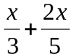 b 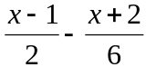

_________________________________ _________________________________

_________________________________ _________________________________

_________________________________ _________________________________

c 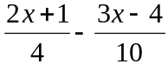 d 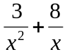

_________________________________ _________________________________

_________________________________ _________________________________

_________________________________ _________________________________

e 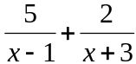 f 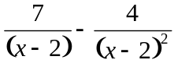

_________________________________ _________________________________

_________________________________ _________________________________

_________________________________ _________________________________

_________________________________ _________________________________

(6 × 1 = 6 marks)

6 Solve each of the following equations.

a 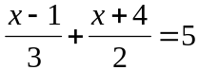 b 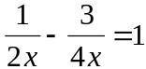

_________________________________ _________________________________

_________________________________ _________________________________

_________________________________ _________________________________

_________________________________ _________________________________

(2 + 2 = 4 marks)

Part C – Extended-response (4 marks)

1 Simplify the following by first factorising the numerator and denominator, carrying out the multiplication or division, and then cancelling common factors.

a 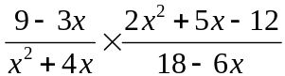

______________________________________________________________________________________

______________________________________________________________________________________

______________________________________________________________________________________

______________________________________________________________________________________

______________________________________________________________________________________

______________________________________________________________________________________

b 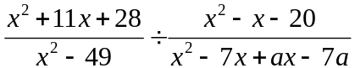

______________________________________________________________________________________

______________________________________________________________________________________

______________________________________________________________________________________

______________________________________________________________________________________

______________________________________________________________________________________

______________________________________________________________________________________

(2 + 2 = 4 marks)

